C29PE Tutorial 2 - Questions and Answers

1. The formula for price elasticity of demand is as follows:
Proportionate (or percentage) change in quantity demanded
Proportionate (or percentage) change in price

This can be summarised as: ΔQ_{d} / mid Q_{d} ÷ ΔP / mid P

The following table shows the quantity of a product demanded at two different prices:

P | Q_{d}
16  14 | 25  35

(a) Calculate the proportionate change in quantity demanded when price falls from £16 to £14.
(Use the first part of the formula, i.e. ΔQ_{d} / mid Q_{d} , to do your calculation.)
ΔQd / mid Qd = 10/30 = 0.33

(b) Calculate the proportionate change in price when price falls from £16 to £14.
(Use the second part of the formula, i.e. ΔP / mid P, to do your calculation.)
ΔP / mid P = –2/15 = –0.13

(c) What is the price elasticity of demand between £16 and £14?
ΔQd / mid Qd ÷ ΔP / mid P = 0.33/–0.13 = –2.5

2. The following diagram shows two demand curves that cross at a price of P₀.
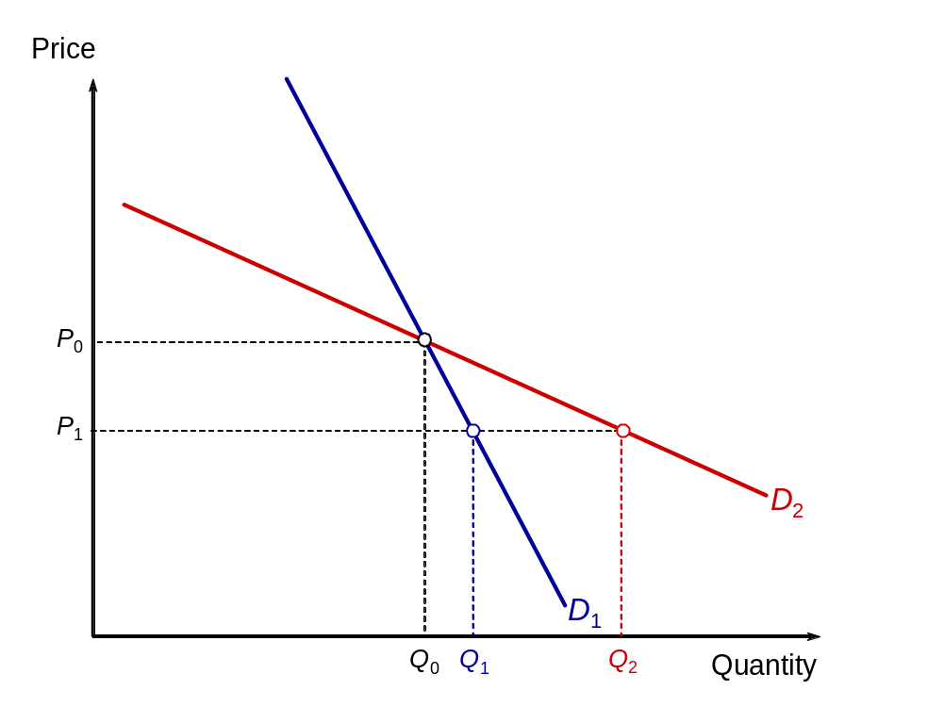
Which of the following statements are true?

- Curve D₁ is inelastic and curve D₂ elastic
False: The price elasticity of demand decreases as you move down a straight-line demand ‘curve’, so you can only compare elasticity at particular points on the two curves or over particular segments.

(b) Demand is more elastic between P₀ and P₁ along curve D₂ than along curve D₁
True: There is a bigger change in quantity demanded for the given change in price along curve D2.

(c) For any given change in price there will be a larger proportionate change in quantity along curve D₁ than along curve D₂
False: The opposite is true.

3. People generally buy goods and services because they expect to gain satisfaction from them. We call this satisfaction utility. An important distinction we make is between total and marginal utility.

- Define total utility (TU)
The total amount of satisfaction a consumer gains by consuming a given quantity of a good or service over a given time period.

- And marginal utility (MU)
The additional satisfaction a consumer gains by consuming one more unit of a good or service within the same time period.

- The following diagram shows the marginal utility (MU) that a consumer gets from consuming different quantities of a product. Assume that the current market price of the product is P.

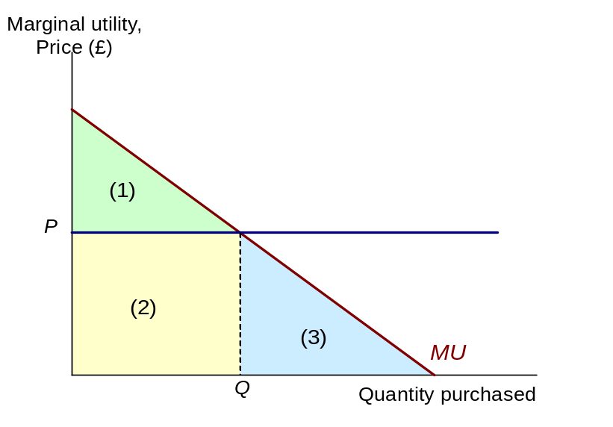 (i) Why is the optimum consumption point at Q?
Because MU = P (consumer surplus is maximised)
(ii) What area(s) represent(s) total utility at Q?
1 + 2 (area under MU curve at Q)
(iii) What area(s) represent(s) the consumer’s total expenditure at Q?
2 (= P × Q)
(iv) What area(s) represent(s) the consumer’s total consumer surplus at Q?
1 (= total utility – total expenditure)

Sample exam questions

4. Discuss briefly whether you consider that market demand or market supply for petrol will be more price elastic. Draw a diagram in which market demand is a downward sloping line, and market supply is an upward sloping line. Choose the slopes to reflect the assumptions about the price elasticities of demand and supply. Mark the market equilibrium as point A on your diagram. At point A, assume that the price of petrol is $1.20 per litre.

- The government now imposes a tax on petrol of $0.60 per litre. Indicate how we can illustrate the effect of the tax (i) on the market supply curve, (ii) on the market equilibrium; and (iii) on the government’s revenues. Mark the market equilibrium as point B.
- Mark point C, on the market supply curve before the tax was imposed, directly below point B. What can we tell from point C?
- The sellers of petrol collect the tax for the government. Why would it be wrong to say that the sellers pay the tax.
- Define the tax incidence which falls on sellers of petrol, and the incidence which falls on buyers of petrol. Using your diagram, which bears the larger proportion of the incidence.
- Relate the answer for part b) to your argument about the price elasticities of supply and demand in 1e). Explain why a relatively inelastic demand, means that governments can generate high tax revenues.

Students should discuss the factors affecting demand and supply elasticities. There is no fixed answer. For example, you might argue that petrol is not an essential product due to the presence of public transport (so demand for petrol is price elastic). Supply may be price inelastic in the short run due to supply bottlenecks. If these are your arguments, expect to see the following diagram:
Price
Price
Price

Supply

A
$1.20

Demand

Quantity of a good

New supply
Price

Supply
B

$X
A
$1.20

$X – $0.60
Demand
C

Q1
Q2
Quantity of a good

(a) Tax causes supply to shift up to the left. Market equilibrium moves from A to B. Government tax revenue increases
(b) At B, the equilibrium price represents the price paid by the consumer. At C, the price corresponds to a value equal to price paid by consumers at B less the tax per unit consumed i.e. $0.60. So, this is the price received by the producers. This means that after taxation, the price paid by consumers become different from the price received by producers. Tax drives a ‘wedge’ between consumer and producer prices.
(c) The point is that collecting the tax is not the same as bearing the burden. For that we need to look at how the tax affects prices
  - (d) Tax incidence for sellers of petrol is equal to the rectangle corresponding to $(1.20 – ( X – 0.60)) * Q2; Tax incidence for consumers is equal to the rectangle corresponding to $(X – 1.20) * Q2. It can be seen that the tax incidence for consumers is smaller than the tax incidence for producers. (Note: Tax incidence of consumers + tax incidence of producers = total tax revenue collected by government)
  - (e) If demand is price elastic, the tax increases market price only slightly. So given the new market price less tax per unit, producers end up bearing a bigger tax burden. If demand is price inelastic, the tax increases market price more significantly. Hence, a greater portion of tax burden can be passed to consumers.

- The market for white coffee is highly competitive in Malaysia, as it is a popular coffee beverage. A market researcher estimated that the demand per day for white coffee in Putrajaya is given by the equation Q = 200/P. The supply of white coffee is perfectly elastic at price of $10 from 0 to 80 cups of coffee per day. When market supply hits 80 cups per day, supply becomes perfectly inelastic.
- Draw a diagram depicting the market for white coffee. Show the equilibrium price and quantities in the diagram. Draw the areas which represent the consumers’ surplus and the producers’ surplus.
- Suppose that the demand for white coffee increases due to advertisements by social media influencers. The new demand curve is now represented by Q = 1600/P. Draw the diagram again and indicate the areas representing consumers’ surplus and producers’ surplus. Comparing with the initial equilibrium, what happens to the new equilibrium price and quantity?
- Explain the effects on prices and quantities if demand continues increasing.

Price
Supply

10

Demand

20
80
Qty

(a) Consumer surplus is the area bounded by demand, supply and the vertical axis. Since market price equal supply there is no producer surplus.

Price
Supply

20
10

New Demand
Demand

20
80
Qty

(b) Equilibrium price and quantity will increase. New consumer surplus is area bounded by new demand, supply, and vertical axis. Producer surplus is now equal to (20 – 10)*80 = 800.

(c) Prices will increase, but quantity will remain capped at 80 units.

Supplementary questions (will not be discussed in class)

- In the mid-1990s, the government in the UK announced that for every 10 per cent rise in the price of cigarettes, the demand is likely to fall by 6 per cent. If this information is correct, what is the value of the price elasticity of demand for cigarettes?
–0.6 (= –6%/10%)

- In each of the following pairs, tick which of the two items is likely to have the more elastic demand. Give reasons for your answer.
√
√
√
(a) Petrol (all brands) Esso petrol
There is no close substitute for petrol. If the price of petrol went up, the quantity demanded would fall only slightly, as people would still need fuel for their cars. If the price of Esso petrol went up, however (assuming that the prices of other brands had not changed), people could easily switch to other brands.

(b) Holidays abroad Bread

People could easily substitute cheaper holidays, at home or abroad, if the price of foreign holidays rose. The substitutes for bread are less close, and people spend a relatively small proportion of their income on bread. A rise in the price of bread, therefore, is likely to result in only a small fall in the quantity demanded.

(c) Salt Clothing

People spend such a small proportion of their income on salt that they could easily afford to pay a higher price – and would probably not even be aware that the price had risen. Do you know the price of a drum of salt?

- Fill in the rest of the following table:
(For the final column use the formula: ΔQ_{d} / mid Q_{d} ÷ ΔP / mid P)

Quantity demanded (000s) | Price  (£) | Total consumer expenditure | Elastic or inelastic demand | Price elasticity of demand
7  9  11  13 | 13  11  9  7 | 91  99  99  91 | elastic  unit elastic  inelastic | –1.5  –1  –0.67

- The figure opposite shows the total utility that Raj, a first-year degree student, would receive from different levels of annual income.

Raj’s total utility from his income
Assume at the moment that his annual income (from an allowance from his parents and some part-time work in a burger bar) is £4000. Spending this rationally gives him a total utility of 500 ‘utils’.
TU
Assume that he is offered the chance to gamble the whole £4000 on the single toss of a coin. If he wins then he doubles his money and has an income of £8000. If he loses then then he has to pay £4000 and so has no income left.

(a) If he takes the gamble, what will be his utility this year if he wins?
700 utils (from a total income of £8000)
(b) If he takes the gamble, what will be his utility this year if he loses?
0 utils (from a total income of £0)
(c) What would be his expected utility from the gamble?
(700 + 0) ÷ 2 = 350 utils
(d) Why is it likely that he will not take the gamble, and thus be risk averse?
If he does not takes the gamble then he has an expected utility of 500 utils, whereas if he takes the gamble he has an expected utility of 350 utils. The greater utility from not taking the gamble is a result of diminishing marginal utility of income. The increase in utility from the additional £4000 he receives if he wins the gamble (200 utils) is less than the fall in utility he experiences (500 utils) if he loses the gamble and his income is reduced by £4000.

Assume now that Raj does not take the gamble but is still worried because there is a 16 per chance that his £4000 will be stolen. An insurance company offers him a full insurance policy against this loss for a premium of £800.
- What is the expected value of taking the gamble (i.e. of not taking out the insurance)?
The expected value = 0.84(£4000)+ 0.16(0) = £3360
- What is his expected utility from taking the gamble (i.e. of not taking out the insurance)?
The expected utility = 0.84(500)+ 0.16(0) = 420utils
- What is his expected utility if he purchases the insurance (i.e. pays the £800 premium)?
This will leave him with £3200 for sure as the insurance company will pay out the £4000 if the money is stolen. This gives him 420 utils of pleasure.
- Would he buy the insurance policy for a premium of £800?
He would be indifferent between buying and not buying the insurance policy. The expected utility from buying the insurance and having £3200 for certain(420utils) is the same as the expected utility from taking the gamble and not buying the insurance (420 utils).
- Would be buy the insurance policy for a premium of £750?
He would buy the insurance as the expected utility from paying the £750 premium and having £3250 for certain must be greater than 420 utils.
- Assume the insurance has many customers in exactly the same position as Raj i.e. facing a 16 per cent change that their income of £4000 will be stolen. How much will it pay out on average in claims per customer? Can it make a profit if it charges a premium of £750?
The insurance company can take advantage of the law of large numbers and predict that 16 out of every 100 customers will each make a claim for £4000. This works out to an average of £640 per customer. As long as the administrative costs of providing each policy per customer are less than £110 (£750 – £640) then the insurance company can make a profit.
- Assume now that when customers like Raj take out the insurance policy they takes less care with their money and the chances of it being stolen increase from 16 per cent to 25 per cent. Explain any problems this might cause the insurance company.
This is an example of moral hazard. The problem for the insurance company is that 1 in every 4 customers on average will now make a claim of £4000 which work out to an average of £1000 per customer. The insurance company will now make a loss if it charges a premium of either £750 or £800.

